**KWAME NKRUMAH UNIVERSITY OF SCIENCE AND TECHNOLOGY**



**COLLEGE OF ENGINEERING**

**ME 492: MANAGEMENT AND ENTREPRENEURSHIP DEVELOPMENT**

**BUSINESS PLAN**

**“**StudySpace**+”**

**By**

Adjei Gideon (3019520)

Danso Isaac (3029420)

Donkor Jesse Jojo (3030120)

Lamptey, Caleb Kwame (3033620)

Ziddah Francis (3041720)

**July, 2024**

Table of Contents

EXECUTIVE SUMMARY 4

1 INTRODUCTION 1.1 Name of the company 6

1.2 Nature of the business 6

1.3 Industry profile 7

1.4 Location of the business 7

1.5 Date of business commencement 7

1.6 Factors in selecting the purposed business 8

ORGANIZATIONAL PLAN 9

Vision and Objective 9

2.2 Organization Chart 10

2.3 Manpower Planning 10

Position and Number of Staff 10

**2.4 Schedule of Tasks and Responsibilities** 11

Key Responsibilities 13

2.5 List of Office Equipment 14

3 MARKETING PLAN 16

3.1 Service Description 17

3.2 Marketing Objectives 17

3.3Target Market 18

3.5 Competition 19

3.6 Market Share 21

3.7 Sales Forecast 22

**Summary of Sales Forecast** 23

3.8 Marketing Strategy 23

4 OPERATIONAL PLANS 27

4.1 Process Flow Chart 27

4.2 Production Schedule 28

4.3 Material Requirements 29

**4.4 Manpower Requirements** 29

4.5 Machine and Equipment 30

4.6 Operation Layout Plan 30

4.7 Location 32

4.8 Operations Overhead 32

5 FINANCIAL PLANS 34

**5.1 Project Implementation Cost Schedule** 34

5.2 Proforma Profit And Loss 34

5.3 Proforma Cash Flow 36

5.4 Administrative Budget 38

5.5 Marketing Budget 39

5.6 Operations Budget 40

CONCLUSION 42

# EXECUTIVE SUMMARY

StudySpace Plus is an innovative business initiative aimed at providing university students with dedicated, comfortable, and accessible study environments. Positioned within hostels on and around the KNUST campus, StudySpace Plus offers a range of services designed to enhance the academic experience, including high-speed Wi-Fi, ergonomic seating, and convenient snack bars.

**Background Problem:** The primary challenge faced by students at KNUST is the overcrowding of existing study spaces and campus facilities, which hinders their ability to find quiet and conducive environments for personal study. The university’s provisions are insufficient to meet the demands of the growing student population, necessitating alternative solutions to address this critical issue.

**Range of Investigation:** Our investigation covers the total enrollment of approximately 85,000 students at KNUST, with a specific focus on the 25,500 students who actively seek out additional study spaces beyond those provided by the university. This target market includes both resident and non-resident students who require accessible and conducive study environments.

**Methods of Analysis:** We conducted a comprehensive market analysis to understand the needs and preferences of our target audience. Surveys and feedback mechanisms were employed to gather data on student requirements for study spaces. Additionally, we analyzed the current market offerings, including direct and indirect competitors, to identify gaps and opportunities.

**Findings or Issues:** Our analysis revealed a significant demand for additional study spaces, with 30% of the student population actively seeking alternatives to the overcrowded university facilities. The key issues identified include the lack of quiet, comfortable environments and the need for accessible amenities such as Wi-Fi and refreshments.

**Arguments and Conclusions from Research:** Based on our findings, we argue that StudySpace Plus can effectively address the identified issues by providing strategically located study hubs within hostels. These hubs will not only offer the necessary amenities but also create a community atmosphere conducive to academic success and will be an avenue to interest students in other services such as technical repairs and interior decor.

**Recommendations:**

* **Promotions:** We should host campus events, distribute promotional materials, and run engaging social media campaigns to build brand awareness.
* **Partnerships:** We should collaborate with hostel administrations and student organizations to enhance visibility and credibility.
* **Service Enhancements:** We should implement loyalty programs and regular feedback mechanisms to ensure high customer satisfaction and repeat business.
* **Advertising:** We should utilize targeted digital ads and campus media outlets to reach our audience effectively.

**Financial Projections:**

* **First Year:** Generate GH₵340,000 from services and snack sales, plus GH₵200,000 from bedspace reservations, totaling GH₵540,000.
* **Second Year:** Increase revenues to GH₵650,000 from services and snack sales, and GH₵250,000 from bedspace reservations, totaling GH₵900,000.
* **Third Year:** Achieve GH₵950,000 from services and snack sales, and GH₵350,000 from bedspace reservations, totaling GH₵1,300,000.

By implementing these recommendations and focusing on continuous improvement, StudySpace Plus will enhance the academic experience for KNUST students and establish itself as the preferred study hub on campus.

# 

# 

# 

# 

# 

# 

# 

## 1 INTRODUCTION 1.1 Name of the company

We introduce **StudySpace Plus**, a new venture dedicated to enhancing the student experience with innovative study solutions on campus.

## 

## 1.2 Nature of the business

Study Space Plus is a first of a kind business idea that seeks to revolutionize how tertiary students study forever. Study Space plus will consist of five main aspects, all working together in harmony to provide a better studying environment for students.

The areas are:

1. A spacious, highly furnished and comfortable learning center for students to collaborate with each other on projects, a place to prepare themselves for upcoming examinations and overall studies.

2. The sale of healthy and delicious snacks will be readily available at our canteens, so students can enjoy their study breaks and quench their thirst. This would alleviate the burden of having to walk a long way from their project discussions for snacks.

3. A computer repair shop to help students when the unfortunate situation of having a computer breakdown occurs.

4. An avenue for new students or freshmen to select the best options when it comes to hostel selections based on their financial capacity and their preferences.

5. The sale of interior decoration items would also be available for students to decorate their rooms and hostels.

The motive behind this business idea is to help students overcome the overcrowding challenges they face when approaching examination periods and also get a place to study in comfort when there is no electricity. It also aims to provide guidance and assistance to students on how to select the best shelters, keep their laptop devices in good shape, and beautify their rooms.

The business will be available to the public six days a week, from 6a.m to 12 a.m from Mondays to Saturdays. It would follow the KNUST academic calender closely in terms of yearly availability.

## 1.3 Industry profile

Study Space Plus operates in the education support services market. This industry provides a wide range of services targeted at improving students' academic experiences, including tutoring and study aids, as well as technical assistance and wellness services. Our distinct set of offerings places us at the confluence of education, technology, and student living services.

## 1.4 Location of the business

This prestigious project would have a main office on the Kwame Nkrumah University of Science and Technology university campus and branches located on all hostels on campus and off campus, and we believe these venues are the ideal location for our business since the market niche we are targeting is university students.

## 1.5 Date of business commencement

The official commencement date for our business is the 13th January, 2025, so as to capture the attention of new students and continuing students and help them settle into their academic year perfectly

## 1.6 Factors in selecting the purposed business

Study Space Plus was founded when the founders of the company, Mr. Adjei Gideon, Mr. Danso Isaac, Mr. Donkor Jesse Jojo, Mr. Lamptey Caleb Kwame, and Mr. Ziddah Francis, realised that most tertiary students of universities became stranded when it came time to study for their exams. They realised that the study spaces offered by the schools became overcrowded, and people could not prepare well enough for their exams. Brainstorming to find a solution to this problem led to the creation of Study Space Plus; however, other factors were also considered in selecting the proposed business, which included

Passion for helping students achieve academic excellence

A better business opportunity

Experience with computer repairs and how they work in general

Better estimated returns on business

Excellent bookkeeping skills

1.7 Future prospects of the business

Study Space Plus intends to develop its services based on student feedback and changing demands. Future plans include expanding to new locations based on the success of the initial location near major tertiary institutions. To supplement our physical presence, we will launch an online platform for virtual study sessions, snack ordering, and remote computer support. Collaboration with Educational Institutions: We want to form relationships with universities and colleges to better integrate our services with the academic environment.

# 

# ORGANIZATIONAL PLAN

2.1 Introduction

### Vision and Objective

**Vision:**

Our vision is to be the most reliable provider of comfortable and accessible to all study spaces equipped with every necessary tool for clients while providing technological, innovative and interior design solutions.

**Objectives:**

1. **Accessibility**

* Establish one hub in the first year of operation.
* Ensure 90% of students in the vicinity of KNUST campus are within 15 minutes’ walk from a Study Space Plus (S2+) hub in the first 5 years of operation.
* Ensure 80% of people around and on campus can access our repair and interior design services by just click on a phone away in the first decade of operation.

1. **Comfort and Facilities:**

* Equip each hub with high-speed internet, high speed computing resources, cushy seats and consultation desks for interactions with our IT and repair experts.

1. **Solution Provision:**

* Provide repair and interior design solutions for 70% of residents in the vicinity of KNUST campus.

1. **Branch Expansion:**

* Open 10 branches each within the first 2 decades to reach a broader student population around University of Ghana and University of Cape Coast.

1. **Customer Satisfaction:**

* Partner with at least three local businesses and campus organizations each year to offer workshops, discounts, and events that enhance the student experience.

## 2.2 Organization Chart

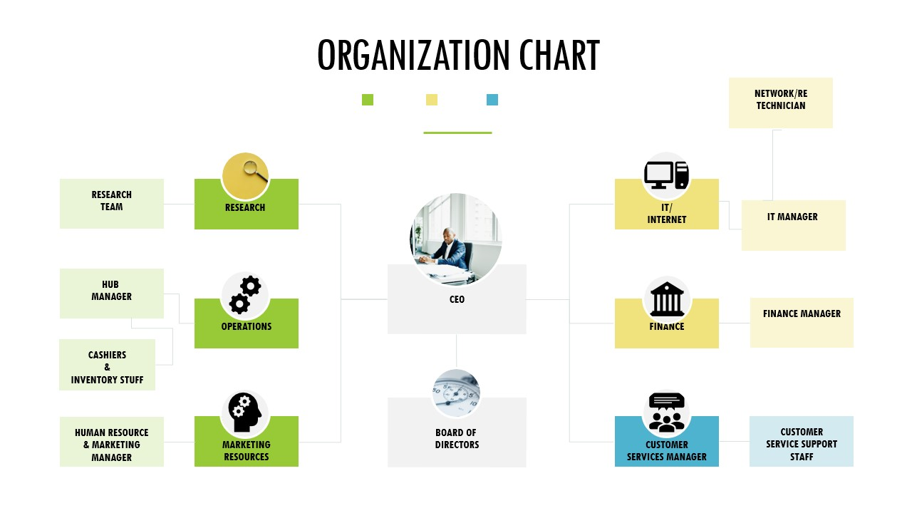

## 2.3 Manpower Planning

### Position and Number of Staff

The overall number of staff that the business need is specified in the table below:

|  |  |
| --- | --- |
| **STAFF** | **NUMBER NEEDED** |
| **Accountant** | 1 |
| **Bookkeeper** | 1 |
| **Sales Team** | 1 |
| **IT research and solutions Team** | 1 |
| **Marketing Manager** | 1 |

Staff Needed For each Hub:

|  |  |
| --- | --- |
| **STUFF** | **NUMBER** |
| **Hub Manager** | 1 |
| **Baristas** | 3 |
| **Cashiers** | 2 |
| **N Inventory Stuff** | 1 |
| **IT Technician** | 1 |
| **Customer Service Representative** | 1 |
|  |  |

# **2.4 Schedule of Tasks and Responsibilities**

#### **Year 1: Establishment and Initial Growth**

|  |  |  |  |
| --- | --- | --- | --- |
| **Quarter** | **Task** | **Responsible** | **Deadline** |
| **Q1** | Finalization of business plan | Board of Directors | Month 1 |
| **Q1** | Secure capital or funding | Finance Manager | Month 2 |
| **Q1** | Find and lease locations for new hubs | Operations Manager | Month 3 |
| **Q2** | Hire key staff (Hub Managers, initial staff) | HR Manager | Month 4 |
| **Q2** | Set up initial study hubs | Operations Manager | Month 6 |
| **Q2** | Develop marketing strategy | Marketing Manager | Month 5 |
| **Q3** | Launch initial marketing campaign | Marketing Team | Month 7 |
| **Q3** | Train staff | HR Manager | Month 8 |
| **Q3** | Open first study hub | Operations Manager | Month 9 |
| **Q4** | Monitor performance and gather feedback | General Manager | Month 10 |
| **Q4** | Adjust strategy based on feedback | Board of Directors | Month 11 |

#### **Years 2-3: Expansion and Market Penetration**

|  |  |  |  |
| --- | --- | --- | --- |
| **Quarter** | **Task** | **Responsible** | **Deadline** |
| **Q1** | Analyze performance of initial hub | General Manager | Month 12 |
| **Q1** | Plan expansion strategy | Board of Directors | Month 13 |
| **Q1** | Recruit additional staff for new hubs | HR Manager | Month 14 |
| **Q2** | Open second and third hubs | Operations Manager | Month 18 |
| **Q2** | Launch localized marketing for new hubs | Marketing Team | Month 16 |
| **Q3** | Implement loyalty program | Customer Service Manager | Month 20 |
| **Q3** | Conduct staff development and training | HR Manager | Month 22 |
| **Q4** | Evaluate customer satisfaction | Customer Relations | Month 24 |
| **Q4** | Plan next phase of expansion | Board of Directors | Month 25 |

#### **Years 4-7: Sustained Growth and Market Leadership**

|  |  |  |  |
| --- | --- | --- | --- |
| **Quarter** | **Task** | **Responsible** | **Deadline** |
| **Annual** | Review and update strategic plan | Board of Directors | Annual |
| **Q1** | Launch new product/service offerings | Product Development | Month 37 |
| **Q2** | Enhance facilities and infrastructure | Operations Manager | Month 42 |
| **Q3** | Form partnerships with local businesses | Marketing Manager | Month 50 |
| **Q4** | Conduct market research and analysis | Marketing Team | Month 48 |

#### 

#### **Years 8-10: Market Diversification and Sustainability**

|  |  |  |  |
| --- | --- | --- | --- |
| **Quarter** | **Task** | **Responsible** | **Deadline** |
| **Q1** | Diversify service offerings | Product Development | Month 85 |
| **Q2** | Optimize operations for sustainability | Operations Manager | Month 90 |
| **Q3** | Expand into new geographical markets | Expansion Team | Month 95 |
| **Q4** | Evaluate long-term financial performance | Finance Manager | Month 100 |

### Key Responsibilities

Board of Directors

* Finalizing business strategy and objectives.
* Securing funding and financial oversight.
* Regular review and strategic adjustments.

General Manager

* Overseeing daily operations.
* Performance monitoring and reporting.
* Implementing strategic initiatives.

Operations Manager

* Setting up and maintaining study hubs.
* Facility management and logistics.
* Coordinating expansion efforts.

Finance Manager

* Managing financial planning and budgeting.
* Ensuring financial health and reporting.
* Securing funding and managing investments.

Marketing Manager

* Developing and executing marketing strategies.
* Market research and competitive analysis.
* Managing branding and promotional activities.

HR Manager

* Recruiting and training staff.
* Implementing employee engagement and retention strategies.
* Ensuring compliance with employment laws.

IT/Internet Manager

* Setting up and maintaining IT infrastructure.
* Ensuring reliable internet services.
* Managing IT support and security.

Customer Service Manager

* Managing customer relations and support.
* Implementing customer feedback mechanisms.
* Ensuring high levels of customer satisfaction.

## 2.5 List of Office Equipment

A well-equipped office is essential for the smooth functioning of any business. Here’s a comprehensive list of office equipment categorized by department and purpose:

**General Office Equipment**

* Desks and Chairs: Ergonomic desks and chairs for staff.
* Computers: Desktop computers or laptops for each employee.
* Printers/Scanners: Multi-function printers and scanners.
* Phones: Office telephones or VoIP phones.
* Stationery: Pens, notepads, staplers, paper clips, etc.
* Filing Cabinets: Secure filing cabinets for document storage.
* Whiteboards and Notice Boards: For meetings and notices.
* Office Supplies: Paper, envelopes, folders, binders, etc.
* Internet Modem/Router: For internet connectivity.

**Specific Department Equipment**

Operations Department:

* POS Systems: Point of Sale systems for transactions.
* Inventory Management Software: For tracking stock levels.
* Coffee Machines: High-quality coffee machines for the coffee shop.
* Refrigerators: For storing perishable items.
* Microwaves: For heating food items.
* Shelving Units: For storing supplies and inventory.
* Barista Tools: Espresso machines, grinders, milk etc.

Finance Department:

* Accounting Software: Software like QuickBooks or Xero.
* Safes: Secure safes for cash and sensitive documents.
* Calculators: Professional calculators for accounting tasks.

Marketing Department:

* Graphics Design Software: Adobe Creative Suite or similar.
* Digital Cameras: High-quality cameras for content creation.
* Video Editing Software: Software like Adobe Premiere Pro.
* Marketing Analytics Tools: Tools like Google Analytics, HubSpot.

IT/Internet Department:

* Servers: For data storage and website hosting.
* Network Equipment: Routers, switches, and cabling.
* Backup Devices: External hard drives or cloud backup solutions.
* Security Systems: Firewalls and antivirus software.

Service Department:

* Customer Relationship Management (CRM) Software: Tools like Salesforce.
* Headsets: Quality head

# 3 MARKETING PLAN

The academic environment at KNUST can be overwhelming, with students constantly seeking quiet and comfortable spaces to study. Overcrowded libraries and sitting areas, noisy hostel rooms, and uncomfortable study rooms often fall short in meeting these needs. StudySpace Plus emerges as a solution, providing dedicated study hubs within campus hostels.  
This marketing plan outlines the strategic approach for launching and establishing StudySpace Plus as a premier provider of study environments on campus. We will delve into a detailed product description, identify and analyze our target market, assess market size, and evaluate the competitive landscape. Furthermore, we will define our desired market share, provide a comprehensive sales forecast, and elaborate on our robust marketing strategy. Each section is designed to provide a clear roadmap for achieving our business objectives and ensuring the success of StudySpace Plus in meeting the needs of university students.

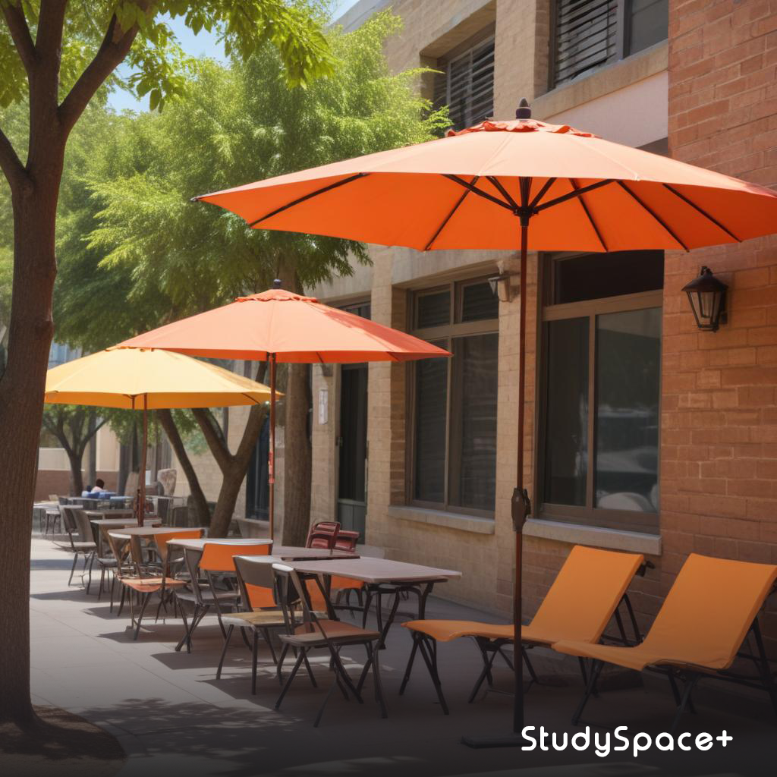

StudySpace Plus Concept

## 3.1 Service Description

StudySpace Plus is designed to be a sanctuary for students seeking an ideal study environment within their campus hostels. Hostels to be selected to host study hubs should have sufficiently spacious compounds to accommodate them comfortably. Each hub should feature ergonomic seating and a serene, well-lit atmosphere, perfectly tailored for long study sessions. High-speed Wi-Fi access is available throughout, ensuring students can connect to online resources without interruption. The hubs also include snack bars stocked with a variety of snacks and beverages, allowing students to refuel without leaving the study area. Furthermore, local businesses can advertise essential services like computer repair and interior décor within the hubs, making it a convenient one-stop-shop for students. A unique aspect of StudySpace Plus is a bedspace reservation policy, to be created in collaboration with hostels, which allows us to reserve and sell bedspaces to students at the start of the academic year. This policy however will be limited to off-campus hostels as on-campus hostels have stricter conditions for securing accomodations. This blend of comfort, convenience, and essential services positions StudySpace Plus as an indispensable resource for students.

## 3.2 Marketing Objectives

1. **Increase Brand Awareness**

* **Objective:** Achieve 70% brand recognition among the student population within the first year.
* **Strategy:** Implement a comprehensive marketing campaign including social media promotions, campus events, and collaborations with student organizations.
* **Measurement:** Conduct surveys and monitor social media engagement to gauge awareness levels.

1. **Capture Initial Market Share**

* **Objective:** Acquire 10-15% of the target market (2,550 to 3,825 students) within the first year.
* **Strategy:** Offer promotional discounts, referral programs, and free trials to attract early adopters.
* **Measurement:** Track membership sign-ups, usage rates, and revenue growth.

1. **Enhance Customer Retention**

* **Objective:** Achieve a 75% retention rate of users from the first to the second year.
* **Strategy:** Introduce loyalty programs, collect and act on user feedback, and continuously improve services based on customer needs.
* **Measurement:** Monitor repeat usage rates, feedback forms, and customer satisfaction surveys.

1. **Expand Service Offerings**

* **Objective:** Introduce at least two additional services (e.g., extended operating hours, new snack options) by the end of the first year.
* **Strategy:** Gather customer input through surveys and focus groups to identify desired services.
* **Measurement:** Evaluate customer feedback on new services and track their usage rates.

1. **Optimize Marketing Spend**

* **Objective:** Achieve a marketing Return-on-Investments of at least 120% within the first year.
* **Strategy:** Allocate budget to the most effective channels, regularly analyze campaign performance, and adjust strategies as needed.
* **Measurement:** Track marketing expenses against revenue generated from marketing activities and calculate Return-on-Investments.

## 

## 3.3Target Market

**Primary Targets:**

Our primary target market consists of university students who reside in campus hostels. These students often face the challenge of finding convenient, comfortable, and quiet spaces to study, close to their living quarters. Given their proximity to the hostels, they are ideally positioned to benefit from StudySpace Plus' dedicated study hubs, which offer a serene environment tailored to their academic needs. By addressing the specific demands of this group—who need both proximity and comfort—StudySpace Plus can provide a valuable solution that enhances their study experience and academic performance.

**Secondary Targets:**

In addition to hostel residents, our secondary target market includes non-resident students who are actively seeking reliable study spaces on campus. These students frequently face the challenge of finding suitable locations away from their primary residences and are drawn to spaces that offer both convenience and functionality. Furthermore, university faculty and staff who require quiet areas for work, meetings, or research constitute a tertiary market. By catering to these diverse groups, StudySpace Plus aims to address the varied needs of the entire campus community. This multi-tiered approach not only broadens our potential customer base but also fosters a dynamic and loyal clientele, as we offer a tailored solution to enhance productivity and comfort for students, faculty, and staff alike.

3.4 Market Size

To gauge the market size, we begin by examining the university's total enrollment, which is estimated at around 85,000 students. Of these, approximately 95%, or 80,750 students, reside in hostels on and around the KNUST campus, making them our primary market. Additionally, non-resident students who may use the study hubs add another potential 4,250 users to our customer base. Taking into account that KNUST provides for the comfortable personal study needs of about 70% of the student population, we identify an overall potential market size of approximately 25,500 students. This significant market size highlights the strong demand for the services offered by StudySpace Plus and indicates a promising opportunity for substantial growth and profitability.   
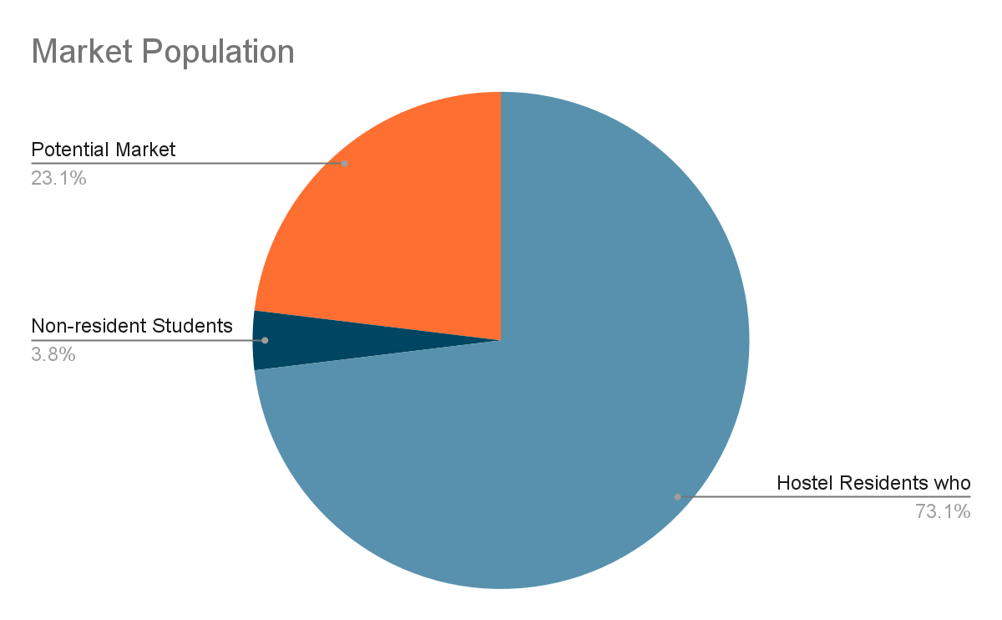

Market Population

## 3.5 Competition

StudySpace Plus will face competition from both direct and indirect sources. Not all students will patronize our hubs, as KNUST provides learning centers that meet the needs of some students. However, the value of StudySpace Plus becomes evident when existing facilities are overwhelmed by overpopulation or when proximity to the student residences is a crucial factor. Our strategic location within hostels ensures convenience and accessibility, addressing these key issues.

**Direct Competitors:**  
Direct competitors include university libraries and designated sitting areas that offer similar dedicated study environments. These facilities are well-established and widely used by students, presenting a challenge for StudySpace Plus to attract users who are accustomed to these traditional spaces.

**Indirect Competitors:**  
Indirect competitors consist of cafes and similar establishments that, while not primarily designed as study spaces, appeal to students due to their quiet environments, Wi-Fi availability, and refreshments. These locations provide an alternative to traditional study spaces and can draw students seeking a more relaxed atmosphere.

StudySpace Plus sets itself apart by being strategically located within hostels and offering a comprehensive suite of services tailored specifically for students. Our hubs feature high-speed Wi-Fi, convenient snack bars, and advertisements for essential services such as computer repairs and interior décor, creating a holistic and student-centric study environment. This strategic positioning and service offering are designed to attract students who prioritize convenience and a tailored study experience.

|  |  |  |  |  |
| --- | --- | --- | --- | --- |
| **Feature/Service** | **StudySpace Plus** | **University Libraries** | **Campus Sitting Areas** | **Cafes** |
| **Location** | Within hostels | Central campus locations | Various campus locations | Off-campus |
| **Proximity to Residence** | High | Moderate to Low | Moderate to Low | Low |
| **Wi-Fi** | High-speed, reliable | High-speed, limited access | Variable | Moderate to High |
| **Seating Comfort** | Ergonomic seating | Standard seating | Basic seating | Comfortable seating |
| **Snack Bar** | On-site | None | None | On-site |
| **Service Advertisements** | Yes | No | No | No |
| **Study Environment** | Quiet, student-focused | Quiet, academic-focused | Variable | Variable |
| **Operating Hours** | Extended hours | Limited to library hours | Varies by location | Varies by cafe |
| **Crowding** | Low to Moderate | High | High | Low to Moderate |
| **Additional Services** | Computer repair, interior décor | None | None | None |

Competitive Analysis Table

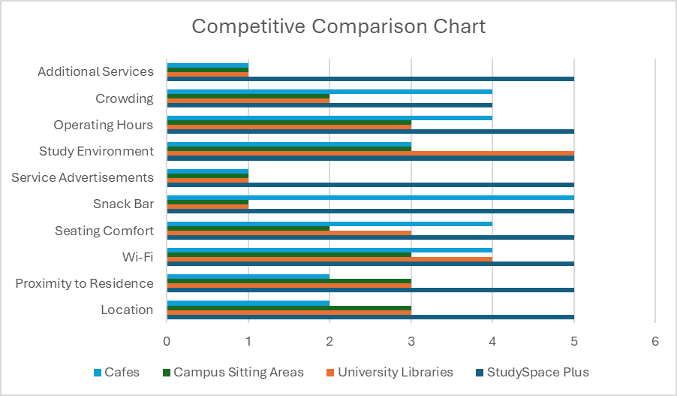

**5 = Excellent/High 4 = Good 3 = Average 2 = Below Average 1 = Poor/Low**

## 3.6 Market Share

Our initial goal is to capture 10-15% of the primary target market of 25,500 students within the first year, translating to approximately 2,550 to 3,825 students. By continuously enhancing our services and responding to student feedback, we aim to increase our market share to 25-30% by the third year, equating to 6,375 to 7,650 students.

This growth will be driven by several key strategies:

1. **Strategic Partnerships with Hostels:**

* Establishing collaborations with hostel administrations to integrate StudySpace Plus into their facilities.
* Ensuring our study hubs are conveniently located within or near hostels to maximize accessibility and convenience for students.
* Working with hostels on exclusive offers and promotions to encourage student use of our study spaces.

1. **Comprehensive Marketing Efforts:**

* Launching a robust marketing campaign to raise awareness and attract students to StudySpace Plus.
* Utilizing social media platforms, campus events, and collaborations with student organizations to create a strong presence.
* Implementing referral programs and offering initial discounts to encourage early adoption and word-of-mouth promotion.

1. **Maintaining High Service Standards:**

* Continuously improving our services based on student feedback to ensure we meet their evolving needs.
* Providing high-speed Wi-Fi, ergonomic seating, and a comfortable, quiet study environment to differentiate ourselves from competitors.
* Offering additional services, such as snack bars and advertisements for essential services like computer repairs and interior décor.

By focusing on these strategic areas, we aim to build a loyal customer base and ensure high retention rates. As more students experience the benefits of StudySpace Plus, we expect positive word-of-mouth and increased demand, leading to a natural expansion of our market share. Achieving these targets will position StudySpace Plus as a leading provider of study spaces on campus. It will establish us as the go-to destination for students seeking a conducive study environment, ensuring sustained growth and long-term success. Our commitment to excellence and student satisfaction will be the cornerstone of this growth, helping us build a strong, reputable brand within the university community.

## 3.7 Sales Forecast

The financial projections for StudySpace Plus are optimistic, reflecting our strategic goals and market potential.

**First Year Projections:** In the first year, we aim to generate GH₵340,000 from study hub services and snack sales. This revenue is based on capturing 10-15% of our primary target market (2,550 to 3,825 students) and charging an average fee for services and snacks. Additionally, we expect to earn GH₵200,000 from bedspace reservations through our partnerships with hostels. This combined revenue of GH₵540,000 represents our initial entry into the market and sets the foundation for growth.

**Second Year Projections:** By the second year, we anticipate increased brand awareness and a growing customer base. As more students become familiar with StudySpace Plus and appreciate its unique offerings, we project our revenues to rise to GH₵650,000 from services and snack sales. This growth is also supported by our enhanced marketing efforts and improved service offerings. Furthermore, bedspace reservation revenues are expected to increase to GH₵250,000 due to stronger partnerships with hostels and higher demand from students. The total projected revenue for the second year is GH₵900,000, reflecting a significant upward trend.

**Third Year Projections:** In the third year, we expect our revenues to reach GH₵1,300,000 from services and snack sales. This projection is based on achieving a 25-30% market share (6,375 to 7,650 students), continuous service improvements, and an expanded range of offerings and hub centers. Bedspace reservation revenues are also projected to grow to GH₵350,000 as our reputation strengthens and more hostels collaborate with us. The total projected revenue for the third year is GH₵950,000, highlighting the robust growth and financial viability of StudySpace Plus.

### **Summary of Sales Forecast**

|  |  |  |  |
| --- | --- | --- | --- |
| **Year** | **Revenue from Services and Snack Sales** | **Revenue from Bedspace Reservations** | **Total Revenue** |
| **Year 1** | GH₵340,000 | GH₵200,000 | GH₵540,000 |
| **Year 2** | GH₵650,000 | GH₵250,000 | GH₵900,000 |
| **Year 3** | GH₵950,000 | GH₵350,000 | GH₵1,300,000 |

These projections underscore the strong growth potential and financial sustainability of StudySpace Plus. Our focus on strategic partnerships, superior service offerings, and effective marketing will drive this growth, making StudySpace Plus a leading provider of study spaces and related services on campus. By continuously adapting to student needs and maintaining high service standards, we aim to achieve and exceed these financial targets.

## 3.8 Marketing Strategy

Our marketing strategy combines promotions, partnerships, service enhancements, and advertising to build brand awareness, attract and retain customers, and establish StudySpace Plus as the leading study hub on campus. Recognizing the importance of a strong brand identity, we will ensure all our equipment features our logo and brand colors, effectively communicating our brand image to our customers. A sample logo is displayed below:

A sample StudySpace Plus Logo

1. **Promotions:**
   * **Campus Events:** Host and sponsor various events such as study sessions, workshops, and social gatherings to engage with students and create a community atmosphere.
   * **Flyers and Posters:** Distribute eye-catching materials in high-traffic areas like dorms, dining halls, and campus walkways to increase visibility.
   * **Social Media Campaigns:** Run engaging campaigns on Instagram, Snapchat, X and WhatsApp to maintain a strong online presence and interact with the student body.
2. **Referral Programs:**
   * Encourage students to refer friends to StudySpace Plus by offering discounts or freebies as incentives. This word-of-mouth strategy leverages existing users to expand our customer base organically.
3. **Partnerships:**
   * **Hostel Administrations:** Collaborate with hostel managers to integrate our hubs into their facilities, making our services more accessible to students.
   * **Student Organizations:** Partner with various student groups to co-host events and promote our services, enhancing our credibility and reach within the student community.
4. **Service Enhancements:**
   * **Loyalty Programs:** Implement loyalty rewards for frequent users to encourage repeat business.
   * **Feedback Mechanisms:** Regularly gather and act on student feedback to continuously improve our services and ensure high customer satisfaction.
5. **Advertising:**
   * **Digital Ads:** Place targeted ads on platforms like Google and Facebook to reach students online effectively.
   * **Campus Media Outlets:** Advertise in university newspapers, on-campus radio stations, and student forums to reach students through trusted campus channels.

|  |  |  |
| --- | --- | --- |
| **Activity** | **Description** | **Timeline** |
| **Campus Events** | Host and sponsor events to engage with students | Monthly |
| **Flyers and Posters** | Distribute in high-traffic areas | Ongoing |
| **Social Media Campaigns** | Run campaigns on Instagram, Facebook, and Twitter | Weekly |
| **Referral Programs** | Offer discounts/freebies for referrals | Launch at start and ongoing |
| **Hostel Partnerships** | Collaborate with hostel administrations | Initial setup and ongoing |
| **Student Organization Partnerships** | Partner with student groups for events and promotions | Initial setup and ongoing |
| **Loyalty Programs** | Implement rewards for frequent users | Launch within first 3 months |
| **Feedback Mechanisms** | Collect and act on student feedback | Quarterly |
| **Digital Ads** | Targeted ads on Instagram, Snapchat, X and WhatsApp | Quarterly campaigns |
| **Campus Media Advertising** | Ads in university newspapers, radio, and forums | Monthly |

**Summary**

By implementing this detailed marketing strategy, StudySpace Plus aims to build robust brand awareness and position itself as the go-to study hub for university students. Our multi-faceted approach, focusing on promotions, partnerships, service enhancements, and advertising, ensures we attract and retain a loyal customer base. The comprehensive nature of this plan, along with the emphasis on student engagement and satisfaction, will help us achieve our growth and revenue targets while establishing a strong presence on campus.

# 

# 

# 

# 

# 

# 4 OPERATIONAL PLANS

The Operational Plan for StudySpace Plus outlines the comprehensive strategy for setting up and managing our innovative study hubs within campus hostels. Our goal is to create a conducive environment for students by providing comfortable study spaces, high-speed Wi-Fi, and a variety of additional services, including a café, tech support, and decor sales. By leveraging strategic partnerships with hostels and utilizing a robust online platform, StudySpace Plus aims to address the growing need for quality study environments and convenient services tailored to student needs. This plan details the processes, resources, and infrastructure required to efficiently operate and expand our services, ensuring a seamless experience for our customers.

## 4.1 Process Flow Chart

The operations of StudySpace Plus will follow a structured flow to ensure efficient service delivery and customer satisfaction. The key processes include

1. Service Offerings Setup:  
 To set up the service offerings for StudySpace Plus, we begin by conducting market research to identify high-demand hostels that have sufficient space and a large student population, which are ideal for our study hubs. Once suitable locations are determined, we collaborate with interior designers to create a conducive study environment. This involves planning the layout to include quiet study rooms, group workspaces, multimedia rooms for presentations and collaborative projects, as well as café areas to provide refreshments and a comfortable setting for students.

2. Partnership Agreements:  
 In forming partnership agreements, we engage with hostel management to secure space and establish terms for reserving bed spaces, incorporating clauses for commissions, service responsibilities, and marketing rights. Additionally, we collaborate with local vendors to supply café essentials, decor items, and tech support equipment, ensuring that all necessary resources are available for the successful operation of our hubs.

3. Platform Development  
 The development of the StudySpace Plus platform involves creating an online platform and mobile app that include features such as bed space booking, snack ordering, and tech support requests. We will conduct thorough beta testing with a select group of students to identify and resolve any issues, ensuring the platform is fully functional and user-friendly before its full-scale launch.

4. Marketing and Promotion:  
 Our marketing and promotion efforts focus on creating targeted campaigns that leverage social media, campus events, and student organizations to highlight the unique features of StudySpace Plus, such as comfortable study spaces, high-speed Wi-Fi, and additional services. We will also introduce promotional offers, including discounts for early subscribers and complimentary snacks for first-time visitors, to attract and retain customers.

5. Service Delivery:  
 Daily operations at StudySpace Plus include managing the study hubs, providing reliable Wi-Fi access, operating the café, handling tech support requests, and overseeing decor sales. We will implement regular quality checks to ensure high standards across all services, including testing Wi-Fi speeds, maintaining café hygiene, and evaluating customer service to ensure a consistent and positive experience for users.

6. Customer Support:  
 For customer support, we offer a 24/7 helpdesk via the app and provide dedicated staff at each hub to assist with inquiries and address any issues. We will establish a feedback system to collect and analyze customer input, enabling us to continuously improve our services based on user experiences and suggestions.

## 4.2 Production Schedule

**Initial Setup Phase**

*Month 1: Market Research and Location Scouting*

· Identify potential hostels and assess demand.

· Negotiate with hostel management and finalize contracts.

*Month 2: Design and Equipment Procurement*

· Collaborate with interior designers for hub layout.

· Order furniture, café equipment, and tech support tools.

*Month 3: Platform Development*

· Start developing the online platform and mobile app.

· Conduct initial testing with a small user base.

**Operational Phase**

*Month 4 Onwards: Full Operations*

· Launch study hubs and online services.

· Regularly update the platform with new features and hostels.

## 4.3 Material Requirements

**Furniture and Fixtures**

· Desks, chairs, tables, shelves, and soft seating for study areas.

· Whiteboards, projectors, and sound systems for multimedia rooms.

**Café Supplies**

· Coffee machines, blenders, refrigerators, and display units.

· Inventory of snacks, beverages, and quick meals.

**IT Infrastructure**

· High-speed internet routers, servers, and backup systems.

· Computers, printers, and other tech support tools.

**Decor Items** Stock of decor items such as lamps, wall art, bedding, and organizational tools.

## **4.4 Manpower Requirements**

To ensure the smooth operation and management of StudySpace Plus, a diverse and skilled team is essential. Our manpower requirements encompass various roles that are critical to delivering high-quality services and maintaining efficient operations. Each role is carefully defined to meet the specific needs of the business, from managing the study hubs to providing technical support and customer service. Below, we outline the key positions and the responsibilities associated with each role.

**Management Team**

1. Business Manager: Oversees overall operations, financial planning, and strategic growth.

2. Operations Manager: Manages daily operations, including staff schedules and hub maintenance.

3. Marketing Manager: Develops and implements marketing strategies.

4. IT Manager: Oversees tech support services and maintains IT infrastructure.

**Operational Staff**

1. Hub Coordinators: Manage day-to-day activities at each study hub.

2. Customer Service Representatives: Provide assistance to students, handle inquiries, and manage bookings.

3. Café Staff: Baristas and attendants responsible for food preparation and sales.

4. IT Technicians: Provide tech support and maintenance for student devices and hub equipment.

## 4.5 Machine and Equipment

In supporting the diverse range of services offered by StudySpace Plus, we require a variety of machines and equipment tailored to each aspect of our operations. These assets are crucial for maintaining the functionality and efficiency of our study hubs, café, and tech support services. From high-speed internet infrastructure to café appliances and tech support tools, each piece of equipment is selected to ensure optimal performance and a seamless experience for our users. Below, we detail the specific machines and equipment necessary for each area of our business.

**Café Equipment**

· Coffee machines, espresso makers, smoothie blenders, and warming ovens.

· Vending machines stocked with snacks and beverages.

**IT Infrastructure**

· High-capacity servers for the online platform and mobile app.

· Secure Wi-Fi routers with sufficient bandwidth to handle peak usage.

**Multimedia Equipment**

· Projectors, screens, and sound systems for presentations and multimedia use.

· Video conferencing equipment for virtual group meetings.

## 4.6 Operation Layout Plan

The Operation Layout Plan for StudySpace Plus is meticulously designed to provide a comfortable and efficient environment for students, ensuring that all services are easily accessible and user-friendly. The layout is divided into several key areas, each tailored to meet specific needs, from quiet study spaces to social and collaborative zones, as well as support services and retail offerings.

**Study Hubs**The study hubs are the core component of our operation, designed to cater to a variety of study preferences and group sizes. The Quiet Study Room is a soundproof area dedicated to individual study, offering a serene environment equipped with comfortable seating and ample desk space to minimize distractions and maximize focus. This area is intended for students who require a quiet and undisturbed atmosphere to concentrate on their studies.  
  
In addition to quiet areas, the hubs feature Group Workspaces with flexible seating arrangements. These spaces are designed to facilitate group discussions and collaborative work, with movable tables and chairs that can be easily reconfigured to accommodate different group sizes and needs. This adaptability allows for dynamic interactions, making it ideal for study groups, brainstorming sessions, and collaborative projects.  
  
For more specialized needs, our Multimedia Rooms are equipped with projectors, whiteboards, and video conferencing tools. These rooms support a range of activities, from delivering presentations and practicing speeches to conducting virtual meetings and collaborative projects that require multimedia resources. This setup is particularly beneficial for students preparing for presentations or participating in remote group work.

**Café Areas**The café areas within each hub are designed to provide convenient and high-quality refreshments. The Main Café is centrally located within the hub, offering a diverse menu of snacks and beverages to cater to various tastes and dietary preferences. This area serves as a social hub where students can relax and recharge between study sessions, fostering a sense of community within the hub.In addition to the main café, strategically placed Vending Corners are available in various study areas. These corners feature vending machines stocked with a selection of snacks and drinks, providing quick and convenient access to refreshments without the need to leave the study area. This setup ensures that students have access to food and beverages at all times, catering to those who may prefer a quicker, self-service option.

**Tech Support Desk** The Tech Support Desk is a crucial component of the StudySpace Plus offering, providing on-the-spot assistance for students experiencing technical issues. The desk is centrally located within the hub to ensure easy access for all users. Staffed with knowledgeable IT technicians, the desk is equipped with Service Stations that contain the necessary tools and equipment for diagnosing and repairing common issues with laptops, tablets, and other tech devices. This service aims to minimize downtime for students and ensure that their technology needs are promptly addressed, allowing them to focus on their studies.

**Decor Shop** The Decor Shop within each hub provides a retail space for students to purchase decor items and appliances, enhancing their living and study environments. The Display Area is thoughtfully organized to showcase a variety of products, ranging from practical items like lamps and desk organizers to decorative pieces that add a personal touch to student spaces. This area is designed to inspire students and help them visualize how different items can enhance their rooms.  
  
In addition to product displays, the shop includes a Consultation Desk where students can receive personalized advice and recommendations from our staff. This service is particularly valuable for students looking to revamp their rooms or seeking specific decor solutions. The consultation desk also facilitates purchases and helps coordinate any additional services, such as delivery and installation, ensuring a seamless shopping experience.

Overall, the Operation Layout Plan for StudySpace Plus is designed to create a welcoming and supportive environment that caters to the diverse needs of students. By integrating study, social, and support spaces, we aim to provide a holistic experience that enhances student life both academically and personally.

## 4.7 Location

**Primary Locations**

* Focus on large campus hostels with high student density and ample space for setting up study hubs.
* Criteria include accessibility, demand for study spaces, and willingness of hostel management to partner.

**Expansion Plan**Consider expanding to off-campus housing complexes and nearby student residential areas based on demand and success of initial hubs.

## 4.8 Operations Overhead

**Rent and Utilities**

* Monthly rent for hub spaces within hostels, including utility costs such as electricity, water, and internet.
* Maintenance costs for equipment, furniture, and facilities.

**Staff Salaries** Competitive wages for management and operational staff, including benefits such as health insurance and professional development opportunities.

**Maintenance and Supplies**

* Regular maintenance and repair of equipment and facilities.
* Inventory management for café supplies and decor items.

**Marketing and Advertising**

* Budget allocation for digital marketing, campus promotions, and partnerships with student organizations.
* Costs for promotional materials, events, and campaigns.

**Insurance and Legal**

* Insurance coverage for property, liability, and employee protection.
* Legal fees for contract negotiations, compliance with regulations, and intellectual property protection.

# 5 FINANCIAL PLANS

## **5.1 Project Implementation Cost Schedule**

The Project Implementation Cost Schedule outlines the financial requirements for launching StudySpace Plus. This plan includes the initial setup, development, and operational phases necessary to establish study hubs in campus hostels.

**StudySpace Plus – Project Implementation cost**

|  |  |
| --- | --- |
|  | **AMOUNT (GH¢)** |
| **Start-Up Fund** | **1,400,000** |
|  |  |
| **Establishment Costs** |  |
|  |  |
| Office Installation and Assets | 100,000 |
| IT Infrastructure and Systems | 150,000 |
| Advertising and Public Relations | 80,000 |
| Initial Employee Compensation | 300,000 |
| Legal and Licensing Fees | 50,000 |
| Working Capital | 200,000 |
|  |  |
| **Total Establishment Costs** | **880,000** |
|  |  |
|  |  |
| **Funding Gap/Available for Future Growth** | **520,000** |

## 5.2 Proforma Profit And Loss

The Proforma Profit and Loss statement projects the anticipated revenue, costs, and profitability of StudySpace Plus over the next three months. This statement helps in understanding the financial viability and potential growth of the business.

**StudySpace Plus - Income Statement** (Profit and Loss) For the Three Months Ending August 29, 2024

|  |  |  |  |  |  |  |
| --- | --- | --- | --- | --- | --- | --- |
|  | Pro Forma Income Statement | |  |  |  | |
| For the Quarter ended August 29, 2024 |  |  |  |  |  | |
|  |  | June | July | August | **Total (GH₵)** | |
|  |  | **GH₵** | **GH₵** | **GH₵** |  | |
|  |  |  |  |  |  | |
| 1 | Sales Revenue | 160,000 | 180,000 | 200,000 | **540,000** |  |
| 2 | Cost of Sales | (48,000) | (54,000) | (60,000) | **(162,000)** | **S T U D Y S P A C E**  **P L U S** |
| 3 | Gross Profit | 112,000 | 126,000 | 140,000 | **378,000** |
| **Operating Expenses** |  |  |  |  |  |
| 4 | Advertising and Public Relations | (20,000) | (22,000) | (25,000) | **(67,000)** |
| 5 | Compensation and Employee Benefits | (50,000) | (55,000) | (60,000) | **(165,000)** |
| 6 | IT Infrastructure and Systems | (15,000) | (17,000) | (20,000) | **(52,000)** |
| 7 | Miscellaneous Operating Costs | (10,000) | (12,000) | (14,000) | **(36,000)** |
| 8 | Total Operating Expenses | (95,000) | (106,000) | (119,000) | **(320,000)** |
|  |  |  |  |  |  |
| 9 | Net Operating Income | 17,000 | 20,000 | 21,000 | **58,000** |
| 10 | Interest Expense | (2,000) | (2,000) | (2,000) | **(6,000)** |
| 11 | Net Income before Taxes | 15,000 | 18,000 | 19,000 | **52,000** |
| 12 | Income Tax Expense | (6,000) | (7,000) | (7,500) | **(20,500)** |
| 13 | Net Income after Taxes | 9,000 | 11,000 | 11,500 | **31,500** |
|  |  |  |  |  |  |
| **Net Income after Interest and Tax Expenses** | |  |  |  | **31,500** |

## 5.3 Proforma Cash Flow

The Proforma Cash Flow statement provides an overview of the cash inflows and outflows, ensuring that StudySpace Plus maintains a positive cash balance throughout its operations.

StudySpace Plus – Cash Flow Statement

For the Three Months Ending August 29, 2024

|  |  |  |  |  |  |  |
| --- | --- | --- | --- | --- | --- | --- |
|  | Pro Forma Cash Flow Statement | | |  |  |  |
| For the Quarter ended August 29, 2024 |  |  |  |  |  |  |
|  |  | June | July | August | **Total (GH₵)** |  |
|  |  | **GH₵** | **GH₵** | **GH₵** |  |  |
| **Cash Flows from**  **Operating Activities** |  |  |  |  |  |  |
|  | **Net Income** | 9,000 | 11,000 | 11,500 | **31,500** |  |
|  |  |  |  |  |  |
|  | **Net Cash Provided by Operating Activities** |  | | |  |
| 1 | Asset Depreciation and Amortization | 5,000 | 5,000 | 5,000 | **15,000** |
|  |  |  |  |  |  |
|  | **Changes in Working Capital** |  | | |  |
| 2 | Increase (Decrease) in Accounts Receivable | (10,000) | 5,000 | (10,000) | **(15,000)** |
| 3 | Increase (Decrease) in  Inventory | (5,000) | 5,000 | (10,000) | **(10,000)** |
| 4 | Increase (Decrease) in Accounts Payable | 5,000 | 5,000 | 5,000 | **15,000** |
| 5 | Increase (Decrease) in ShortTerm Debt | 0 | 0 | 0 | **0** |
| 6 | Net Cash Provided by Operating Activities | 14,000 | 31,000 | 1,500 | **36,500** |
|  |  |  |  |  |  |
| Cash Flows from  Investing Activities |  |  |  |  |  |
| 7 | Purchase of Property, Plant & Equipment | (0) | (0) | (0) | **(0)** |
| 8 | Net Cash Used in Investing  Activities | (0) | (0) | (0) | **(0)** |
|  |  |  |  |  |  |
| Cash Flows from  Financing Activities |  |  |  |  |  |
| 8 | Proceeds from Long-Term Debt | 0 | 0 | 0 | **0** |
| 9 | Net Cash Provided by  Financing Activities | 0 | 0 | 0 | **0** |
| 10 | Net Increase in Cash | 14,000 | 31,000 | 1,500 | **36,500** |
| 11 | Cash at the Beginning of the Period | 46,000 | 60,000 | 91,000 | **46,000** |
| 12 Cash at the End of the Period | | 60,000 | 91,000 | 92,500 | 82,500 |

## 5.4 Administrative Budget

The Administrative Budget details the costs associated with running the business operations of StudySpace Plus, including salaries, office supplies, and utilities.

StudySpace Plus – Administrative Budget

For the Three Months June, July, and August

|  |  |  |  |  |
| --- | --- | --- | --- | --- |
| **Expense Category** | **June GH₵** | **July GH₵** | **August GH₵** | **Total GH₵** |
| Office Installation and Assets | 100,000 | 85,000 | 80,000 | 265,000 |
| IT Infrastructure and Systems | 150,000 | 140,000 | 140,000 | 430,000 |
| Advertising and Public Relations | 80,000 | 75,000 | 80,000 | 235,000 |
| Initial Employee Compensation | 300,000 | 305,000 | 305,000 | 910,000 |
| Legal and Licensing Fees | 50,000 | 50,000 | 50,000 | 150,000 |
| Total Administrative Expenses | 680,000 | 655,000 | 655,000 | 1,990,000 |
|  |  |  |  |  |

**Office Installation and Assets:** This includes expenses related to the physical setup of the office, such as furniture, computers, and other necessary equipment.

**IT Infrastructure and Systems:** This covers the costs associated with setting up and maintaining IT infrastructure, including hardware, software, and network systems.

**Advertising and Public Relations**: These are the expenses related to advertising and promoting StudySpace Plus to potential users.

**Initial Employee Compensation:** This includes the compensation and benefits for the initial employees hired during these three months.

**Legal and Licensing Fees:** These are costs related to legal advice, licensing, and regulatory compliance necessary to operate the business.

## 5.5 Marketing Budget

The Marketing Budget outlines the expenses for promoting StudySpace Plus, ensuring that students and hostels are aware of the services offered.

StudySpace Plus – Marketing Budget

For the Three Months June, July, and August

|  |  |  |  |  |
| --- | --- | --- | --- | --- |
| Marketing Activity | June GH₵ | July GH₵ | August GH₵ | Total GH₵ |
| Digital Advertising | 20,000 | 30,000 | 30,000 | 80,000 |
| Social Media Campaigns | 20,000 | 15,000 | 15,000 | 50,000 |
| Print Advertising | 10,000 | 10,000 | 5,000 | 25,000 |
| Promotional Events | 10,000 | 10,000 | 10,000 | 30,000 |
| Flyers and Brochures | 5,000 | 5,000 | 5,000 | 15,000 |
| Public Relations Activities | 15,000 | 5,000 | 15,000 | 35,000 |
| Total Marketing Expenses | 80,000 | 75,000 | 80,000 | 235,000 |

Digital Advertising: Invests more in the later months to maintain a strong online presence.

Social Media Campaigns: Consistent campaigns across all three months to engage with the student community.

Print Advertising: Balanced presence in print media to reach students and parents.

Promotional Events: Regular events to keep the momentum and engagement high.

Flyers and Brochures: Continuous distribution throughout the three months to ensure visibility.

Public Relations Activities: Higher initial investment with a strong push again in August to maintain a positive brand image.

## 5.6 Operations Budget

The Operations Budget includes the costs necessary to maintain and manage the study hubs, covering manufacturing, maintenance, and transportation expenses.

StudySpace Plus – Marketing Budget

For the Three Months June, July, and August

|  |  |  |  |  |
| --- | --- | --- | --- | --- |
| Expense Category | June GH₵ | July GH₵ | August GH₵ | Total GH₵ |
| Office Installation and Assets | 100,000 | 85,000 | 80,000 | 265,000 |
| IT Infrastructure and Systems | 150,000 | 140,000 | 140,000 | 430,000 |
| Initial Employee Compensation | 300,000 | 305,000 | 305,000 | 910,000 |
| Maintenance and Repairs | 20,000 | 30,000 | 35,000 | 85,000 |
| Transportation | 5,000 | 6,000 | 7,000 | 18,000 |
| Total Operational Expenses | 575,000 | 566,000 | 567,000 | 1,708,000 |

# CONCLUSION

StudySpace Plus offers a new answer to the problems KNUST students face when they try to find good places to study. By setting up comfy study spots in campus dorms, StudySpace Plus wants to make college life better for students. We give them everything they need to study well: fast internet comfy chairs, places to get snacks, shops to fix computers, and nice-looking rooms.

We've looked at what students want, and we found that about 30% of them are looking for other places to study because the university's spaces are too crowded. By putting our study spots in dorms, we can meet this need and create a place where students can come together to do well in school.

The money outlook looks good, with income set to grow a lot in the first three years. Our plans to market and promote, along with team-ups and better services, will make sure customers are happy and come back.